**BASIC FUNCTION AND TYPES**

Introduction

Safety devices

INTRODUCTION

In the mining industry it is an accepted fact that no mining operations can be accomplished without a winder. No matter what the type or make, the winder is one of the most important units in mining operations.

In this module the following will be discussed:

1 Basic function

2 Safety devises.

Over- and under wind trips (bottom overwind)

Over speed protection

Three-turn warning

Mechanical overwind trips

Ultimate overwind trip

Jack catches

Lock-bell interlock

Slack rope device

Rope coil device

Wrong direction warning

Fast/slow braking

Deceleration shadowing

3 Winder Safety Circuits

Winder safety circuit

Back-up safety circuit

Winder lockout circuit

Emergency Stop

Slack Rope

Over speed protection

Signal Interlocking

No Start Interlock

Men/Rock Change over

Overwind / Underwing Protection

Conveyance Monitoring Safety Circuit - (Slack / tight rope, pole, door, emergency stop etc.)

Marshall Device- (incline shafts only)

Headgear Overwind/Underwing

Camera Overwind/Underwing

BASIC FUNCTION

The reason a mine must have winders to carry on mining operations is that the winder is the only means by which men and material can be conveyed between surface and underground working levels. At the end of the shift men must be transported to surface.

The mineral-bearing rock broken by the Miners underground can only be conveyed to surface by a winder. If it were not for the winder, the gold-bearing rock could not eventually be transported to the gold plant for treatment.

Most winders are situated on ground level near the shaft. From the drum of the winder the rope (single drum) or ropes (double drum) are fed over the sheave wheels above the shaft and attached to the conveyances. The sheaves are fitted on the headgear. The single-drum and double-drum winders will be discussed later in this module. Fig. F.C. 9 – 1.1.1 shows a headgear with the ropes leading down to the winder house.

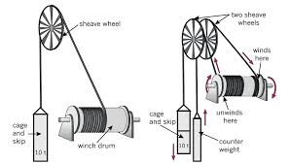

The Keep winder is normally situated on the top of the headgear directly above the shaft. More detail about the Keep winder will be explained later in this module. Fig. F.C. 9 1.1.2 shows a typical headgear for a Keep winder.

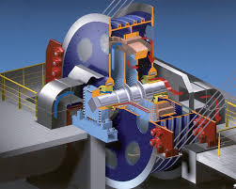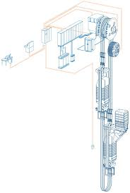

The winders on a mine can be used on vertical or incline shafts. It is merely a question of adapting the sheave wheels to accommodate the ropes.

SAFETY DEVICES

WINDER SAFETY CIRCUIT

The Safety Circuit is a collection of protective devices, connected in series. Therefore, if any one of the monitored units, or conditions is not in the desired condition, the Safety Circuit will be in a tripped condition.

If the safety Circuit is tripped, the Winder Brakes will automatically apply, therefore winding can only take place when the Safety Circuit is reset, or in a healthy condition. In this way one ensures that no winding takes place should a fault condition exists.

The Safety Circuit can be divided into 3 main sections

1. Winder Safety Circuit

2. Back-up Safety Circuit

3. Winder Lockout Circuit

The Winder will the “Lockout”, thus not allowing the brakes to be lifted until the fault is corrected and the Winder Lockout Circuit is rest. Whilst the Winder is locked out, power cannot be applied to the motor and neither can the brakes be lifted.

Safety Circuits vary considerably from Winder to Winder, due to age and with the new Winders being more comprehensively protected to ensure reliable safe operation at all times.

A brief description will be given to typical Safety Circuit units, and conditions that are monitored, is listed below, but these items are not specific to any particular Winder.

One thing common to all winders is the safety device, which protect the winders. Some are required by law and others have been added through experience.

The Electrician and the Fitter are responsible for the testing of the safety devices. It varies from mine to mine that am responsible for certain safety devices?

In this module we will discuss only briefly the operation of the safety devices.

OVERSPEED PROTECTION

The over speed alarm is a warning device that will give the driver an alarm if the maximum allowed speed is exceeded, if this is then further exceeded it will result in the Winder being tripped.

MEN/ROCK CHANGE OVER

This system is used on Rock Winders to move the overwind position from the bank to the tip. If a changeover from men to rock or vice versa is attempted whilst the Winder is in motion, it will cause the Safety Circuit to trip.

FAST/SLOW BRAKING

It can be appreciated that if the winder is running at full speed when a trip-out occurs, it would be detrimental to the machine and to the people traveling in the conveyance if the brakes were applied at a fast rate. Thus, by means of cams driven off the depth indicator drive, the valves that operate the brakes are so actuated that in the fast moving area in the shaft the brakes would be applied at a slow rate in case of a trip-out. By means of the same cams when the conveyance is near the end of the wind, the brakes would be applied at a fast rate. When operating in the shaft away from the mechanical cams, there is an electrical switch operated through the speed governor linkages on the speed controller that converts the brakes to fast braking second speed on the winder. This is to enable accurate decking at levels in the slow braking area.

***Lilly controller***

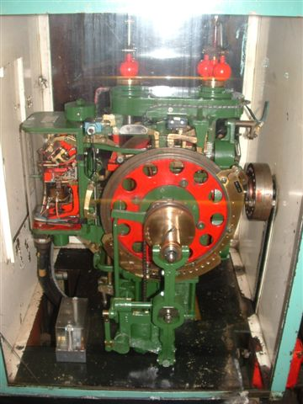

The device which is used on most winders to control the overwinds, under winds and over speeds is the Lilly controller. It is a safety device driven by gears; bevel gears and shafting that are connected to the drums of a winder. Each drum drives its own separate controller.

Each Lilly controller is fitted with one or two sets of centrifugal governor balls, which are driven, by a separate set of gears situated in the Lilly controller itself. The governors are used for over speed prevention.

**The Lilly has 13 devices, which enable it to perform correctly, namely: -**

1. **2 Overwind switches**
2. **2 Underwing switches**
3. **4 Over speed switches**

**1 Warning of over speed**

**1 Warning of retardation**

1. **1 Acceleration solenoid (if installed)**
2. **1 Wrong direction switch**
3. **1 Backing-out switch**

These devices trip the safety circuit when the switches are opened. They are explained simply as follows: -

**Overwind Switches**

There are 2 overwind switches, one for men and one for rock/material.

The overwind limit cam is adjusted to a position where it will engage the roller of the arm which operates the overwind switch. When the upper extremity of the wind is about to be exceeded, the overwind switch will be opened thus opening the safety circuit and tripping the winder. Overwind/Underwing switches are provided on the Mine Winder Controller of any Winder. Once the Winder has been tripped by one of these conditions, the driver can only recover from this condition by using the backing out switch.

The backing out switch permits the Safety Circuit to reset, but if the brakes are lifted before power is applied in the correct direction. If power is applied in the wrong direction, it will cause the Winder to trip again.

**Underwing Switches**

There are 2 underwing switches, one for men and one for rock/material.

The Regulations only refer to a safety device for preventing an overwind. However, this really includes an underwing. An underwing is, in fact, an overwind at the bottom of the wind.

Overwind/under wind switches are provided on the Camera if a Winder. Once the Winder has been tripped by one of these conditions, the driver can only recover from this condition if the Safety Circuit bridged out.

**Over speed Switches**: Warning of Over speed and Warning of Retardation

The 4 over speed switches are:

two for men, one at the bank and one in the shaft, and

2 for rock, one at the bank and one in the shaft.

When the winder drums are revolving, the governor balls attached to the Lilly controller revolve. As the drum speed is increased the centrifugal force set up by these revolving balls causes them to spread and as they spread, a connecting rod moves the floating contact of the over speed warning device closer to the stationary contact.

Should the winder be driven above a pre-determined speed, these contacts will meet and sound an audible warning? This warning indicates that the speed of the winder must be reduced. Should there be a slight increase in speed however, then the pressure exerted on the stationary contact by the floating contact will be sufficient to open the over speed switch in the safety circuit and trip the winder.

When the conveyances operated by a winder approach the upper or lower extremities of the shaft the speed of travel has to be gradually reduced.

When approaching this danger zone, a retarding cam, which is attached to the dial of the Lilly controller, engages a roller. The roller is attached to an arm, which causes a rod to bring the floating contact of the over speed warning nearer to the stationary contact.

The retarding cam is so profiled that the gap between these two contacts becomes less and less as the conveyances approach the end of the wind.

As this gap decreases, less movement of the governor balls (that is a lower

winding speed) is required to operate the audible alarm and the over speed trip switch.

Where Lilly controllers are fitted with two sets of governors, they both serve the same purpose that is to operate the over speed warning and tripping mechanisms. One arrangement allows for the finer setting as required when the conveyance is approaching its upper and lower limits.

**Accelerating Solenoids (Seldom Used)**

It is not always necessary for the top conveyance to start its descent at the same slow speed that is necessary when it approaches either the bank or tip.

Accelerating solenoids may be fitted to the Lilly controller which, when energized, open up the gap between the floating and stationary contacts. The opening of this gap allows the conveyance to be driven away from the bank or tip at a speed faster than that of the original approach speed.

The accelerating solenoids are usually operated by switches fitted to the Lilly controller and by a cam on the cam dial and directional switches fitted to the controller or drum shaft.

**Wrong Direction Switch**

This switch is opened should the controller be moved and the brake released in the wrong direction, after tripping in the overwind or underwing position. It prevents the winder being driven in the wrong direction.

**Backing-out Switch**

When a conveyance is driven past the trip mark at the top or bottom of the shaft and the overwind or underwing switch has been caused to operate and trip the main circuit breaker, the brakes are brought on automatically. It will then be necessary for the driver to reset the winder to drive the conveyance back to the correct mark.

The backing-out switch is connected up with the special directional switches in the master controller.

These switches ensure that the driver can only drive the conveyance in the correct direction away from the overwind or underwing condition. If the driver moves the control lever in the wrong direction, the main circuit breaker will again trip out.

DECELERATION SHADOWING

On the speed controllers there is a cam that actually monitors the deceleration rate of the winder. When the conveyance reaches the position where deceleration must start, the profiled cam starts to make the over speed gap smaller, so if the winder does not gradually slow down, it will trip on over speed. Fig. F.C. 9 – 1.1.7 shows the deceleration cam and connecting linkage to the over speed contacts.



***Bell-brake interlock***:

Prevents the driver from releasing the brakes of the winder, after he gave a signal to the banksman or the onsetter. Only the banksman or the onsetter can unlock the winder’s brakes by giving a signal to the driver. The picture on the left indicates that the brake is locked, and the picture on the right indicates that the brake is unlocked. When the driver transmits a signal to the onsetter or the banksman the solenoid de-energise to lock the brake. When the onsetter or banksman transmits a signal to the driver the solenoid energises and unlocks the brake.

The Mines and Works Act and Regulations “There shall be in use a device which automatically prevents the conveyance or conveyances being raised or lowered after the winding-engine driver has given a signal on the circuit of the locked-bell system provided for interchanging signals with the bank or on the circuit of the locked-bell system provided for interchanging signals with the established points below the bank from which winding is normally carried on, until he has received a signal on each of the circuits on which he gave a signal”.

So, from the above it can be seen that once the Driver has given a signal to the Banksman or the onsetter, he is unable to move the winder until he has received a signal from the Banksman and the Onsetter. An added safety device wired into the locked-bell system is the 10-second delay.

This device prevents the Driver from moving the winder even though he has received this signals until 10 seconds has elapsed and the “all clear” light comes on. This allows the person giving the signal entry into the conveyance.

SIGNAL INTERLOCKING

During men winding the lock bell shaft System is interlocked with the Safety Circuit. This is to ensure that the correct procedure is followed whilst men are being conveyed. After the signals have been completed, there is a ten second delay before the Signal Interlock Trip Relay closes.

If the driver attempts to move the Winder before this period has lapsed, the Safety Circuit will trip. This interlock is overridden when the brake lever is in the on position and the power lever in the off position, to allow for Auto wind materials to take place.

Some of the older Winders use the Broomfield Dixon device that mechanically interlock with the levers.

***Clutch-brake interlock***

Prevents the driver from releasing the brake of an un-clutched drum. The un-clutched, drum is the drum that is going to stand still, it is only suspended by the brake. Some winders are equipped with a rag-and-sprags, to support secure the drum.

***Mechanical cam***

This is a mechanical trip out. The mechanical cam is situated between the winding drum and the driver’s footplate. It consists of a dial with cams fitted to it. It is driven from the drum. When the conveyance passed a certain point in the headgear the mechanical cam will activate the exhaust valve of the brakes to apply the brakes.

EMERGENCY STOP

If any emergency stop push- button is activated the Safety Circuit will trip

SLACK ROPE DEVICE

Should the skip or cage become jammed or stuck in the tip or at the bank, slack rope will be played out when the Driver attempts to move the conveyances down. This is dangerous, because should the conveyance become dislodged and suddenly fall free, the sudden tightening of the rope could cause it to snap. Therefore, the slack-rope device has been installed.

Across the rope raise about 600 mm below the rope, a steel wire rope is strung over a pulley and attached to the operating level of a switch. Thus, should the winder rope become slack, it will sink down and push the steel wire rope down, causing the switch to operate.

On a man winder the switch on operating will sound an alarm in the Driver’s cabin. On an automatic winder the winder safety circuit will trip and stop the winder.

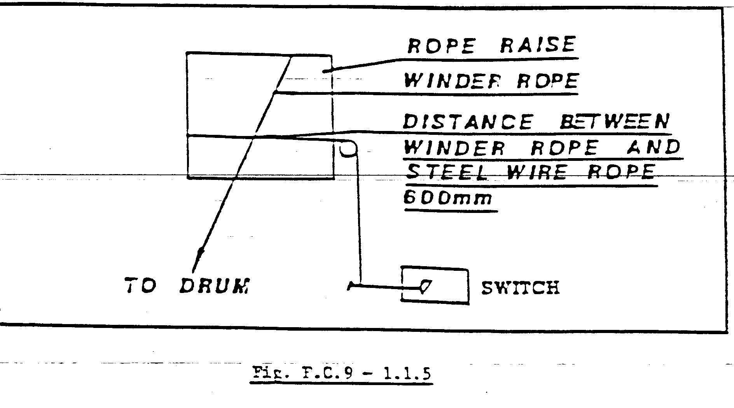

In some cases, instead of the steel wire rope an insulated rail or girder, connected to an electrical circuit, is placed across the rope raise under the winder rope. If the winder rope goes slack and touches the insulated rail, the electrical circuit is actuated and operates the alarm or trip.

This device is situated where the ropes leave the engine room. Slack rope can only occur when the conveyance that is going down the compartment. With a manual winder the driver will be warned, but an automatic winder will trip out. The slack rope device will only be activated when the conveyance got stuck in the upper area of the shaft. It will not be activated when the conveyance got stuck in the lower area of the shaft, because of the weight of the rope.

STATIC SLACK ROPE DEVICE

This device is normally mounted in the Winder house at the rope opening. It consists of a roller mounted across the rope hole just below the winding rope with a weight and limit switch actuator to trip the Winder should the winding rope come into contact with the roller which is normally pivoted on two bearings. The disadvantage of this slack rope device is that it would only detect slack rope in the first 30 to 50 meter of the shaft, thereafter it is normally inoperable as the weight the rope from the sheaves wheel to the drum, compared to the weight of the rope in the shaft which will be greater then, thus no sag will appear to operate the static slack rope device.

The general arrangement of the slack rope device is basically identical on all the Winder. The operation of the device is acceptable but subject to limitation depth, wiring to Safety Circuit etc.

Testing in most cases is done by pulling the device down by hand, which is practical way for doing daily checks. Slack rope simulation by sprigging should be done when practical, for example when cutting front ends.

The arrangement is typical of most shafts with the supporting steel being dependent on the building arrangement. The distance of the roller from the rope and the size of the balancing weights are dependent on site conditions. The slack rope trip is initiated by a lever arm limit switch and fine setting is achieved by turning a threaded stud.

If a slack rope is detected, the Winder is tripped. When the Winder is moved thereafter, it can only be moved in conjunction with the backing out switch, in the direction that will rectify the slack rope.

***Bad coiling***

Bad coiling is when the rope in not coiling properly on the drum. Bad coiling can only be experienced with the upcoming conveyance. It can cause the driver to stop incorrectly on the marks. This device is normally situated below the drum. On a manual winder the driver will be warned by an alarm, but an automatic winder will trip out

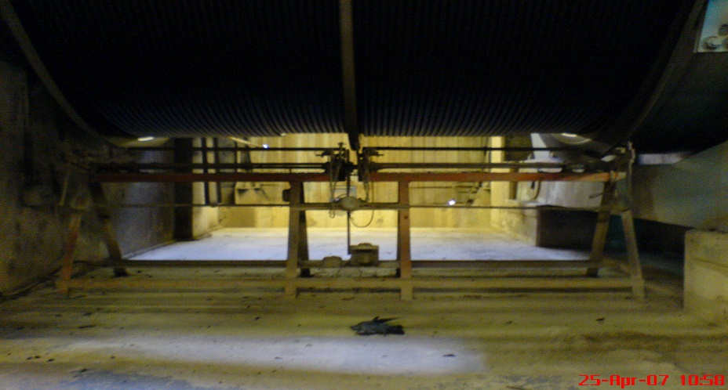

ROPE COIL DEVICE

A further safety device on a winder is the rope coil device or the rope miss-coil device. This device is arranged to check that bad coiling on the drum does not take place. It must be appreciated that should the rope not coil properly on the drum and start heaping up in one position, the drum circumference increases and the position of the ascending conveyance in the shaft will not correspond to the indicator.

This device consists of a steel bar or pipe arranged parallel with the drum, and not further than half die diameter of the winder rope, from the top layer on the drum.

The bar or pipe is connected to a switch, so that if the bar or pipe is moved, the switch operates and sets off an alarm.

As in the case of the slack rope device, the bar or pipe can be insulated and be connected to an electrical circuit, which is actuated if the rope comes in contact with the bar or pipe.

WRONG DIRECTION WARNING

A wrong direction warning device or Phillips device, as it is commonly called is connected in all winder controls. This alarm or warning is operated through a switch operated by a car driven off the depth indicator drive and a contact in the master controller operated by the Driver’s power lever. This warning normally starts to operate when the ascending conveyance is more or less three turns from the bank or tip. This is a safety device that warns the Driver against moving off in the wrong direction when he moves away from the bank or tip. This must not be confused with the three-turn warning.

PHILLIPS PROTECTION DEVICE-WRONG DIRECTION

The Phillips Protection Device provides a warning to the driver if the conveyance is in the bank area and power is applied in the wrong direction. The wrong direction would be that, the conveyance could move further ups the headgear towards overwinds trips, rather than downs the shaft.

THREE TURN WARNING

The Driver is warned of the arrival of the ascending cage, skip, other means of conveyance at not less than three turns of the drum below the bank and there must be a warning signal, which is usually audible.

TACHO FAILURE

If there is a loss of electrical output from the tacho generators that is used for control and ESCORT system, it will trip the Winder Safety Circuit.

If, however, one drum is unclutched provision is made to prevent the Winder from being tripped, because there is no output from the tacho on the stationary drum.

SHAFT SAFETY DEVICES

SKIP STUCK IN TIP DEVICE

This is a way of detecting slack rope with a skip in the tip position. This is purely an electrical circuit based on the direction in which the Winder is to travel when the brakes are released out of the tip and timing circuit to detect that the skip has reached a pre-determined position in a pre-determined time. Should the skip no trip this position in the time set, The Safety Circuit will trip.

STATION GATE INTERLOCK

This device is used to ensure that all the station gates are closed before the Winder can move off. This comprises of hard-wired series connection of all the bank and underground station gate limit switches. If the shaft gates are closed the Winder is permitted to start wind but is not in operation while the winder is in motion.

A gate override facility for the bank and underground are wired via the key switch on the lock bell system, to facilitate the loading and unloading of cars and long material. This override is connected to the spring return to centre side of the switch to prevent the operator from permanently overriding the station gates.

With the station gate interlock being connected in series, it makes it very difficult to detect which gate open, and therefore, the telemetry system is used to show the status of the shaft gates and is used purely as an indication system, for fault finding purpose. Other information such as dam-levels, pressures etc. is also brought to surface via the telemetry system.

Some shafts have the latch fitted the standard gate latch on the left-hand side with a slightly modified latch to the right.

In most cases fitting of the standard latch to existing gates would require new gates completely, therefore various latch systems are used.

ULTIMATE LIMIT -TARZAN WIRE IN HEADGEAR

All the shafts are fit with the normal steel wire stretched across the winding compartments. The wire is sometimes stretched across individual compartments or when two compartments of the same Winder are adjacent then the wire is testchede across them both. In all cases the wire is fixed to the headgear steelwork on one side and to the limit switch on the other side via a series of pulleys.

In some cases, the final limit is a large limit switch with a wheel attached to the lever arm which will strike a cam attached to the conveyance.

The main reason for choosing it over the Tarzan wire is to simplify the resetting of the system in the event of an overwind past the final limit, as it is normally difficult to pull a new wire across the compartments.

SKIP PROTRUDING DEVICE AT LOADING BOX AREAS

This device is normally installed just below the lip of the loading box chute. The device consists of a wire tensioned across the winding compartment and the front side of the skip plus minus 150 mm below the loading box chute. The

device will operate if material protrudes from the skip and should be positioned such that it should trip the machine at the loading box at a very low speed to prevent damage to shaft steelwork. This circuit will trip the Safety Circuit.

SPECTACLE PLATES

This is a mechanical device mounted in the headgear to arrest the conveyance should an overwind occur. This device will ensure that the rope is detached when the humble hook passes through the spectacle plate and the scissors action of the humble hook will ensure that the conveyance is supported in the spectacle plate.

JACK CATCHES

This is a mechanical arresting device situated in the top headgear below the spectacle plate. The device is designed such that it will arrest the conveyance when an overwind has occurred should the spectacle plate a humble hook fail to arrest the conveyance.

Important factors to be checked with mechanical overwind arrangements to ensure safe operation is listed below.

In the event of a complete overwind, that means the conveyance (skip or cage) is pulled up to the very end of travel in the headgear, the rope will be detached from the conveyance. This operation is described fully in the shaft modules. The detached conveyance is arrested by the jack catches and is thus prevented from plummeting down the shaft. The Mines and Works Act and Regulations “Where

winding is carried on in a shaft there shall be fitted above the bank spring keeps or jack catches or some other effective contrivance to support any conveyance detached from the winding rope as a result of an overwind”.



SHAFT CONVEYANCE SAFETY DEVICES

This has been the major area of development due to the latest requirements envisaged in the new Mines Occupational Safety and Health act.

THIMBLE SLACK ROPE DEVICE

This device monitors slack rope condition throughout the length of the shaft. The thimble switch is set in such a fashion that it would detect a no load condition on the thimble due to the small movement of the rope around the thimble. In no load condition a small micro limit opens and this contact will then be fed into the cage interface card which in turn will transmit the status of the switch to the transistorised output card on surfaces. The output card will turn energise or de - energise the logic relays for the left and right conveyances which will form part of the logic to create forward and reverse slack and tight rope conditions.

Reports from the mines indicate that the reliable operation of the device is dependent more on a trial and error setting than on an exact science. The areas that affect this are:

. Tightness of splice

. Setting of device

. Corrosion

. Dirt Ingress

In essence the device is too dependent on the individual’s flair to maintain it to be considered a fail-safe Safety device.

Test simulations on surface, for most shafts, invariable test the operation of the Static Slack rope device, due to the sagging effect of the rope between the Winder drum and the sheaves. In order to stimulate slack rope on the continuous device it is necessary to go below bank level, which is not really practical.

It should be noted that for the above reason both the Static and Continuous devices are required and should not be considered as back-ups for each other. (The static device will not operate at depths greater than plus minus 50 meters below the bank).

THE LOADCELL/STRAIN GAUGE SLACK AND TIGHT ROPE DEVICE

These devices will monitor slack and tight rope by means of mounting load cells or strain gauges below or into the transom of the conveyance. This has been made simpler with the design of the load cell in the MK 3 link. The load cells/ strain gauges will physically measure the load in the conveyance and encode their measurement by means of an electronic card. The load cell interface card Incorporates an upper and lower limit threshold which can be adjusted to give a relay output at these pre-set limits. The load cell interface card relay contacts are connected as digital inputs to the conveyance interface card.

This will then via transmission medium duplicate these signals to a transistorised relay output card in the Winder room conveyance-monitoring panel on surface. The outputs are connected to logic relays for left and right hand conveyances, in such a fashion that it would trip the conveyance monitoring Safety Circuit should a slack or tight rope occur.

CONTINUOUS SKIP DOOR MONITORING

This limit or magnetic switch is mounted on the skip door. The switch is connected to the cage interface unit, which will transmit the status of the contact via the transmission medium to surface, where this is converted to a digital output via a transistorised output relay card. This output is connected to the left and right relay logic relays and the circuit is shown in the Drivers reset safety relay logic diagram. This will trip the conveyance monitoring Safety Circuit.

There are various methods, being used to confirm that the skip body has returned to the correct position in the bridle.

The interlocking is done using a magnetic switch fixed to the Bridle with a magnet attached to the skip body. Due to the nature of the locking system it is highly unlikely that the skip can come out of position after leaving the tipping area.

The probability of both stop brackets coming loose or braking simultaneously is remote, therefore the magnetic switch is probably no required, but ensures that the system is electrically interlocked to stop the winder should this occur.

The bottom discharge skips do require some method of confirming skip back in bridle. Various methods are used: -

. Cats whiskers at tip position

. Magnetic switches on the locking levers.

. Magnetic switches on the skip body.

. Magnetic switches on the skip pan.

. Limit switches on the skip Pan.

The best method would seem to be the Magnetic switch on the skip. The magnet is fixed to the underside of the skip pan and the switch is fixed to the bottom transom of the bridle. This gives positive indication that the skip is properly positioned in the bridle, during normal winding in the shaft.

This is a similar device as described in the skip protruding section which consists of a tensioned wire or roller across the winding compartment plus minus 25-30 mm away from the skip door ensure that the skip door is position before it moves down the shaft. Should the wire/roller be struck by the skip a limit switch is operated to trip the conveyance monitoring Safety Circuit.

CAGE/POLE DOOR INTERLOCK DEVICE

With regard to the type of devices used and the manner of fitting, the variations are numerous. Limit and magnetic switches are used in various positions, some inside the cage, some on the outside. Development is ongoing on a large percentage of the shafts with the type of equipment fitted usually dependent on the shaft conditions (wet etc.) and the cage configuration.

Cage door interlock using limit switch on the outside of the cage. A steel pin attached to the sliding door protrudes through a hole in the cage and operates the limit switch lever. Having switch outside deters tampering.

Cage door interlock using a magnetic switch. The switch is fixed to the cage structure with magnet fixed to the sliding door.

The physical appearance of the device is reasonable standard using a limit switch attached to a steel flap. When the pole is pushed through the hole it operates the limit switch. There is some minor variation of the hardware which are required due to cage configuration.

This device is operated via the conveyance monitoring units, which detect the signal from the cage doors or pole switch and via a transmission medium is converted to a transistorised relay output on surface. The logic relays are wire as a parallel circuit with the pole in position switches to form the basis for the cage door Safety relay logic incorporating the cage door override circuit and speed detector. This will trip the conveyance monitoring Safety Circuit.

INCLINE SHAFT SAFETY DEVICES

In addition to over speed, overwind and most of the Safety devices discussed under vertical shafts the following safety precautions had to be added to the incline Winders. This came mostly from the low gradient shafts that developed a new control and brake philosophy for the Winder.

MARSHALL DEVICE

The Marshall device is used on incline shafts for the detection of derailment of the skip or conveyance on either on or two tracks. The detection of derailment is achieved by running a wire, mounted on brackets down either side of the track/tracks, so that in the event of a derailment, the conveyance either touches (earth) or breaks (open circuit the wire.

The unit also monitors short-circuiting of the conductors and provides indication of the operation of droplets on either side.

This device has two independent trip conditions namely;

1. Earth fault

2. Broken wire

Both conditions will trip the Winder Safety Circuit.

Should any rock or material foul the rail and one of the conductors it would cause an earth fault and thereby operate the Safety Circuit, the broken wire operates a relay which is connected to the Safety Circuit should any of the wires be broken in the shaft.

HOPPER CLOSED DEVICE

This Safety device is a wire tensioned across the winding compartments just above an empty hopper plus minus 10 to 15 meters from the hopper-tipping path. Should the hopper not close the wire will detect this condition and trip the Winder.

This device is not installed underground at the loading points, but could be incorporated as a Safety feature to prevent overloading or material protruding from cars when the conveyance is brought to surface.

***Compensating wheel***

It is a detaching hook situated between the conveyance and the winding rope. This hook is used on multi-rope Blair winders. It get into operation in the headgear in the event of a total overwind, the guillotine cut the rope from the wheel.

***Humble hook***

This is a detaching hook, situated between the conveyance and the winding rope. This safety device gets into operation in the headgear, he releases the rope when he gets activated by the spectacle plate, in the event of a total overwind.

***Ultimate limit***

This is an electrical tripping device. It is a thin cable across the shaft, when the conveyance activates it, and it releases the cable from the switch, and the winder trip out.

**ONSETTER SAFETY DEVICES VERTICAL SHAFT**

##### Vertical shaft safety devices

### Spectacle plate: Activates the humble hook

Jack catches: Secures the conveyance in the headgear

Ultimate limit: Electrical trip out. Tarzan wire

Mechanical cam: Activated in the winder room. Apply the brakes

Rock overwind: Trip skip passed the rock trip

Material overwind: Give clearance in headgear for sling work

Men overwind: Trip cage passed men overwind

Bank over speed: Warn or trip winder in bank area over speed

3 Turn warning: Warn driver to reduce speed near bank

Shaft over speed: Warn or trip winder in shaft over speed

Men under wind: Trip winder when past lowest point for men

Rock under wind: Trip winder when past lowest point for rock

Mechanical cam: Activated in winder room. Apply the brakes.

##### SAFETY DEVICES INCLINE SHAFT

Crash beams: At the top of the shaft just below the sheave wheel.

Drop beams Prevents the skip from running back into the shaft.

Tank trap: Prevent the skip from running back into the shaft.

Jack catches: Secures the conveyance in the headgear

Ultimate limit: Electrical trip out. Tarzan wire

Mechanical cam: Activated in the winder room. Apply the brakes

Rock overwind: Trip skip passed the rock trip

Material overwind: Give clearance in headgear for sling work

###### Men overwind: Trip cage passed men overwind

Bank over speed: Warn or trip winder in bank area over speed

3 Turn warning: Warn driver to reduce speed near bank

Shaft over speed: Warn or trip winder in shaft over speed

Men under wind: Trip winder when past lowest point for men

Rock under wind: Trip winder when past lowest point for rock

Mechanical cam: Activated in winder room. Apply the brakes.

Drop rail: Catch a runaway skip

Crash beams: At lowest point in shaft to stop skip.

Marshall device: Two copper wires running from the highest to the lowest point of wind, on both sides of the compartment. If warns the driver when conveyance derailed.

**SAFETY DEVICES BANK/STATIONS**

There are different safety devices on each landing. Safety devices are installed on the bank and on each station to protect persons and equipment. Safety devices must be used in the correct way otherwise it is not effective for the purpose it has been installed.

***Safety devices safe lives.***

When do you remove safety devices on a station or at the bank for the purpose of loading or unloading material in cars?

You may only remove the safety devices when you positioned the cage level with the station or bank. Then you only remove the safety devices to let one car pass through, load the car into the cage, replace the safety device on the landing, and only now you may position the cage to load the next deck of the cage.

The safety devices on the bank and the stations can be:

1. Shaft gates
2. Farm gates
3. RSJ stopper
4. Tank trap with short rails
5. Huizenga device
6. Vela –vale
7. Skid sprags
8. Aeroplane sprags
9. Hinged arrestor
10. Lovelock

Aeroplane sprags Vela –vale

**Fall Arrestor: -** examine the fall arrestor to ensure that:

* The ratchet or stopper operates effectively,
* The casing is not damaged,
* The steel wire rope must be fully extended and examined for loose or broken strands or kinks,
* The attaching hook is not deformed and the safety catch is functional.
* The anchoring point is functional without visual defects.

**FALL ARRESTOR**

CASING

STEEL WIRE ROPE

ATTACHMENTPOINTS

SALA BLOCK

**Use the fall arrestor:**

* Secure the fall arrestor to a pre-determined specified point.
* Secure the rope of the fall arrestor to the hook of the safety harness,

**Shift control gates: -** prevent persons entering the station area to control the persons about to be loaded into a conveyance.

**Turnstiles: -** control the shift and count the permitted amount of persons per conveyance deck.

**Cage Pipe Sprig / T-Sprig: -** placed in the conveyance to prevent rolling stock moving out of the conveyance and damaging shaft equipment during transportation.

**Conveyance doors: -** secure persons inside the conveyance and prevent injuries.

**Shaft fencing: -** prevent person, tools, equipment and rolling stock falling down the shaft.

**Lock bell Robot lights** “Red” the winder can move and indicate danger; **“Green”** the winder brakes are locked and safe for persons to enter or leave the conveyance.

**Vula Vala**:• safety drop rails – typically located on a rail track across the entrance to shaft

stations. Their function in such a location is to prevent inadvertent access of vehicles

(such as may be used on the working level of the mine) to the shaft, as required by

Regulation 16.61.2.1. Special interlocked safety drop

rails (the “vula-vala device”) areused at the brow

of inclines to form an “airlock” and soprevent

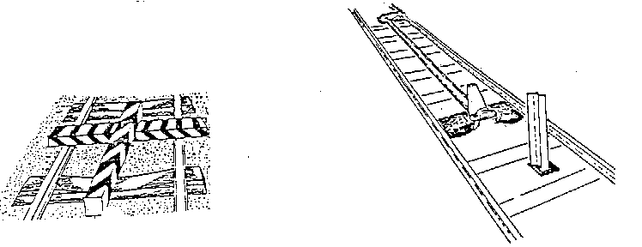

vehicles and materialcars entering the shaft

except under proper control;

###### **H:\private 017.jpg**

